DEVELOP A MOBILE APPLICATION

|  |  |
| --- | --- |
| Date | 4th November 2022 |
| Team ID | PNT2022TMID28767 |
| Project Name | IoT Enabled Smart Farming Application |

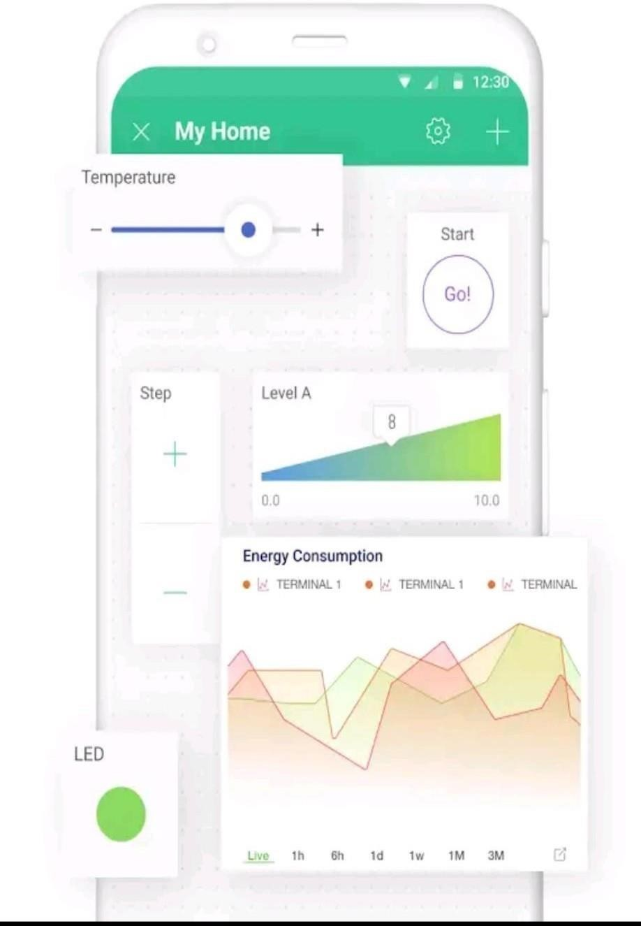

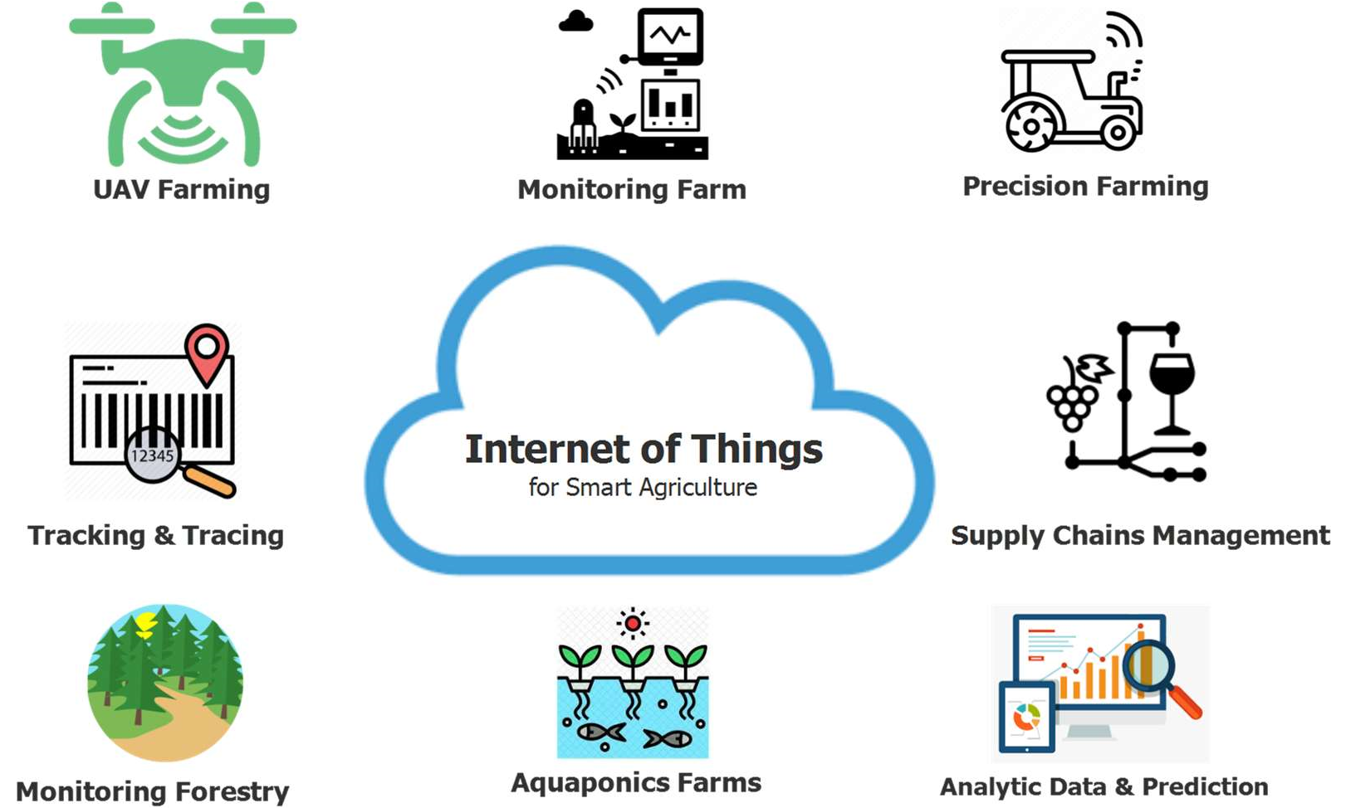

(a). An illustration of IoT applications for smart agriculture

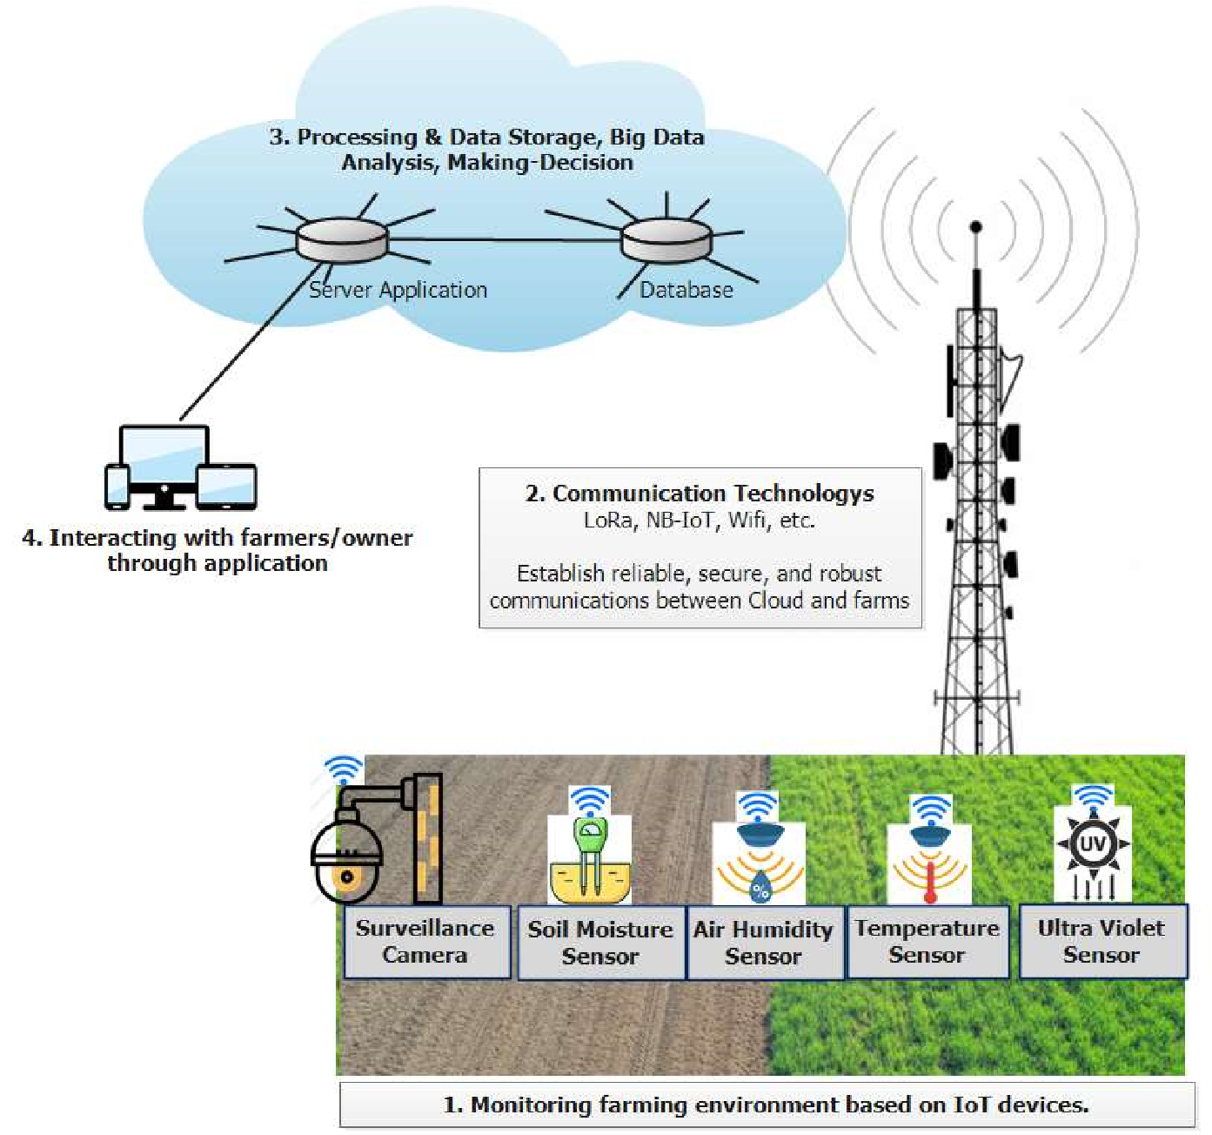

(b). An illustration of IoT ecosystems’ architecture for smart agriculture

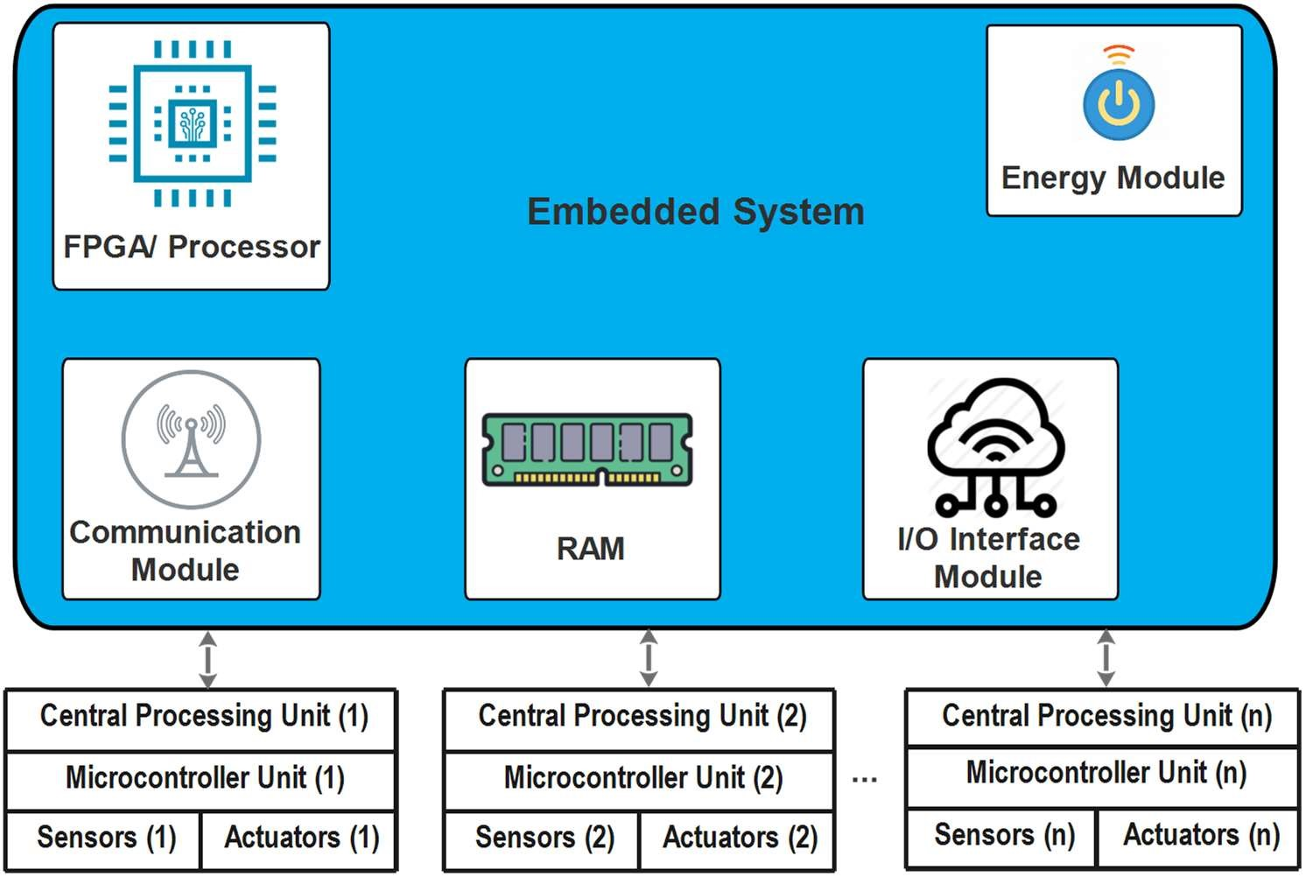

(c). An illustration of the common architecture of an IoT device

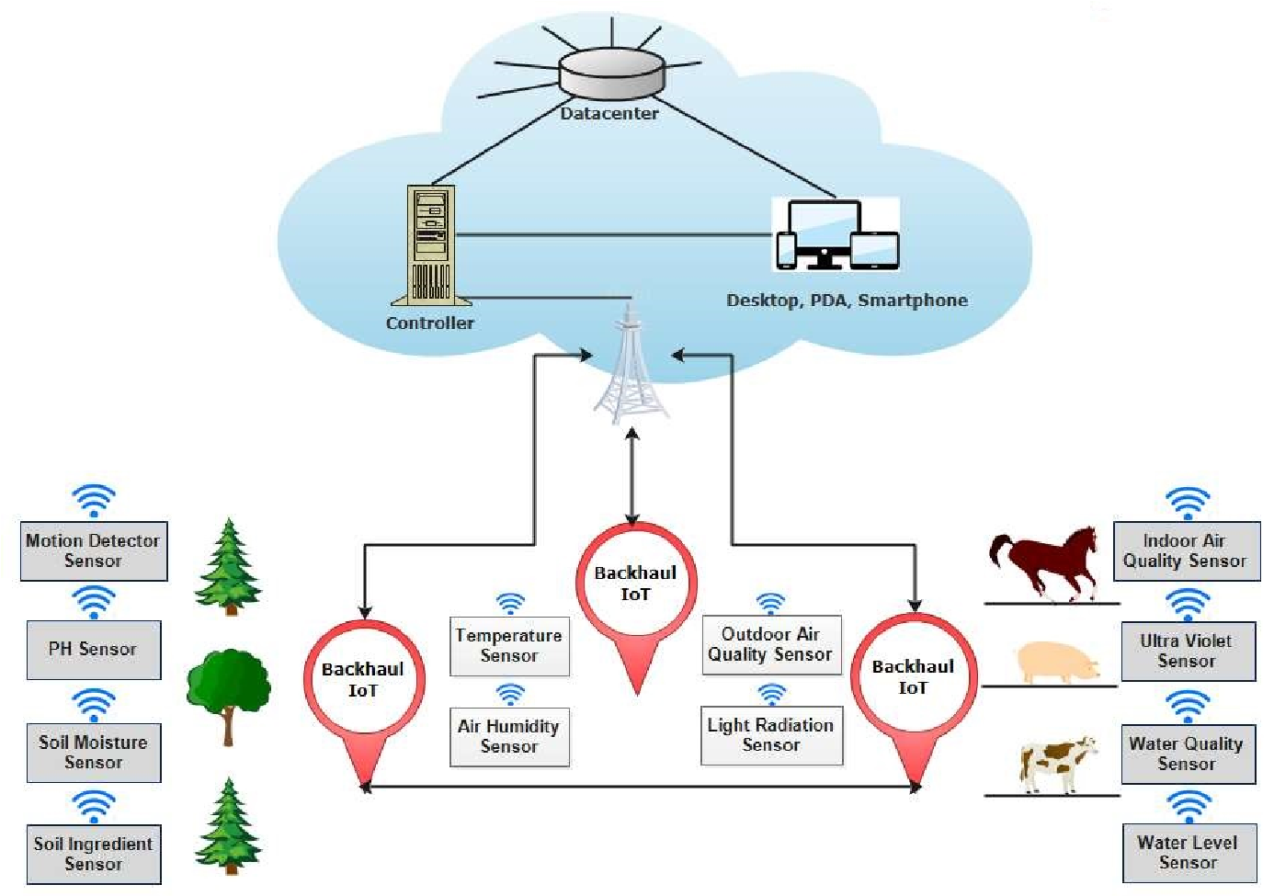

(d). An illustration of the common IoT-based smart agriculture topology

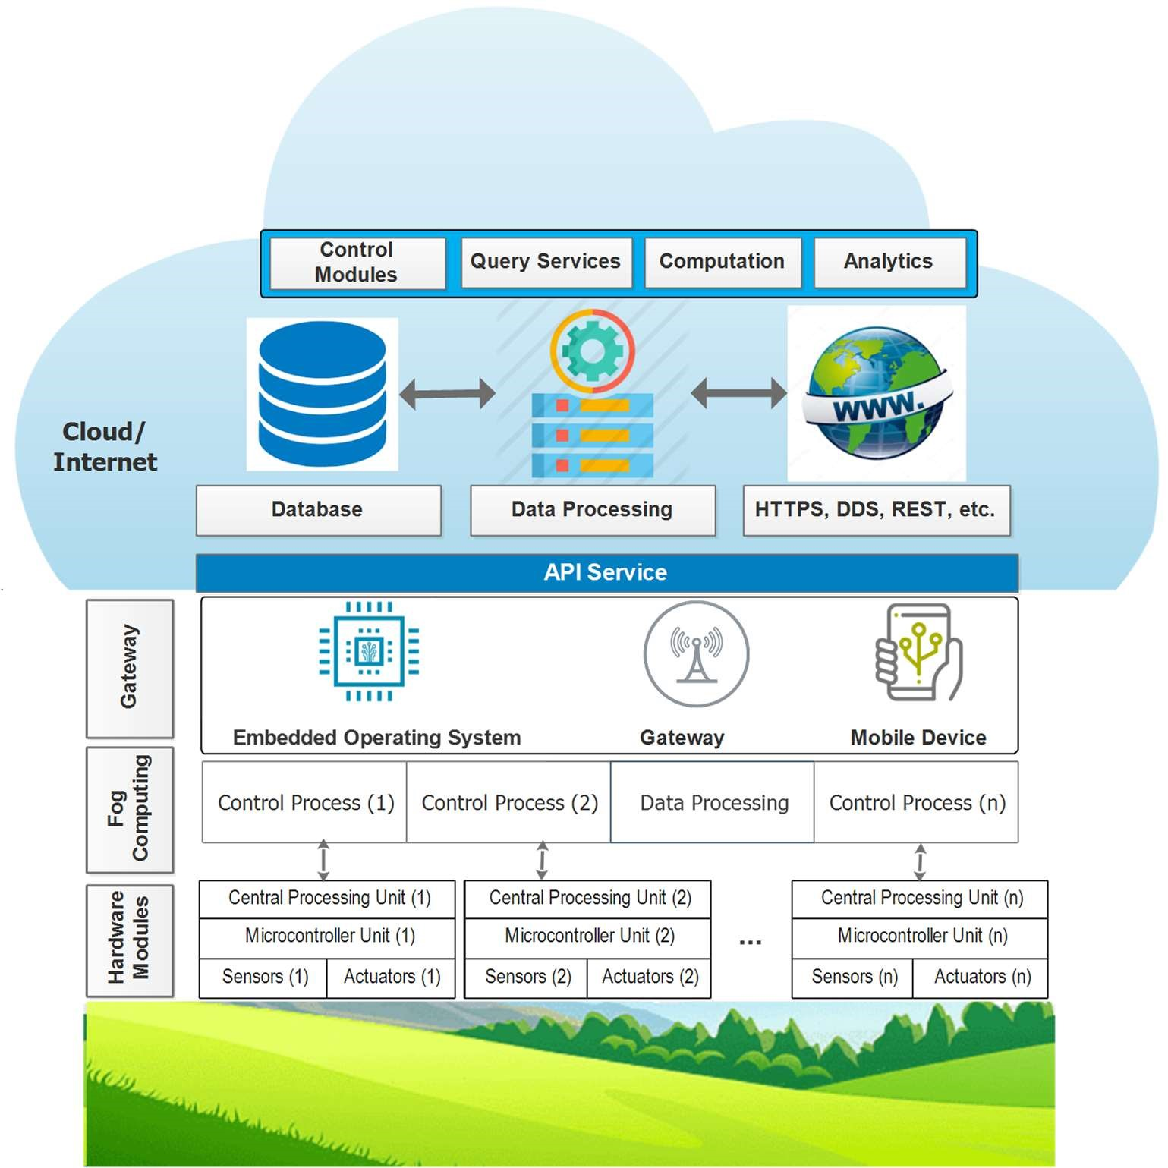

(e). Cloud-assisted IoT-based precision agriculture platform

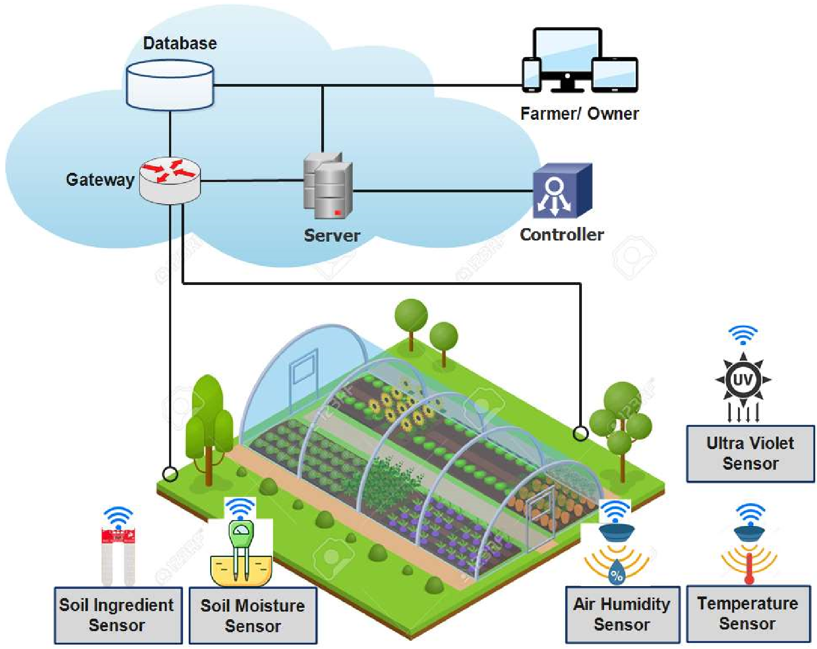

(f). An illustration of IoT application for monitoring farming conditions in a greenhouse